EmpowerWin Print Setup on the File Menu
In EmpowerWin from File on the Menu bar the user selects Print Setup.
EmpowerWin opens a response window that allows the user to select an EmpowerWin document, label,etc. and specify the Windows printer to default when EmpowerWin presents a Print Setup response window.
This information is NOT stored in the EmpowerWin database. It is stored in a specific folder on the workstation where the path has the Windows username in it.
The code below is from the UserSettingManager class. Empower gets the Environment.SpecialFolder.ApplicationData path and appends \EmpowerFinancials to it.
Namespace Configuration.Preferences
Public Class UserSettingManager
Implements Composition.IProviderManager(Of IUserSettingProvider)

Private Sub New()

End Sub

Public Shared Function GetUserSettingPath() As String
Dim strUserSettingsPath = System.IO.Path.Combine(Environment.GetFolderPath(Environment.SpecialFolder.ApplicationData), "EmpowerFinancials")
If Not System.IO.Directory.Exists(strUserSettingsPath) Then
Try
System.IO.Directory.CreateDirectory(strUserSettingsPath)
Catch ex As Exception
strUserSettingsPath = String.Empty
End Try
End If
Return strUserSettingsPath
End Function
On EFWS08 that resulted in the following path
C:\Users\RobertMurray\AppData\Roaming\EmpowerFinancials
which had the following files
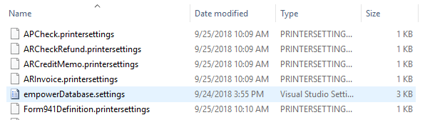
.
.
.

The files can be opened in Notepad.

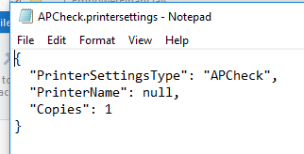

\\\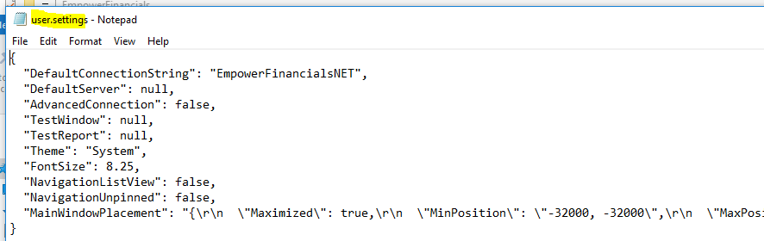

Additional Info to clean up

Empower user settings are stored in the folder
C:\Users\thutter.EXCHANGE\AppData\Roaming\EmpowerFinancials
in the file
user.settings
Here’s an example
{
"DefaultConnectionString": "EmpowerFinancialsNET",
"DefaultServer": null,
"AdvancedConnection": false,
"TestWindow": null,
"TestReport": null,
"Theme": "Light",
"FontSize": 8.25,
"NavigationListView": false,
"NavigationUnpinned": false,
"MainWindowPlacement": "{\r\n \"Maximized\": true,\r\n \"MinPosition\": \"-1, -1\",\r\n \"MaxPosition\": \"-1, -1\",\r\n \"NormalPosition\": \"0, 0, 480, 346\"\r\n}"
}
For us there can also be a user(debug).settings file.
The printer settings are stored in the same folder.
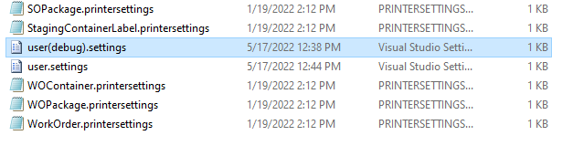
In the namespace Configuration.Preferences.Files there is a class called UserSettings.vb that loads the settings.

